Pacing Algorithms Usage Methodology

Introduction
A Pacing Algorithm (PA) is an important component of the Genesys Web Engagement (GWE) solution. This document is written for users who are already familiar with the basic ideas and terminology of the outbound or proactive campaigns. It provides a high-level description of the PA and some recommendations for its usage.
In general, GWE applications monitor customers on the web and try to connect them to the contact center agents by sending special invites to the customers and organizing chat sessions between these two parties.
A typical GWE campaign that relies on the PA has the following workflow scenario:
- Predicting number of invites to be sent to the web customers. This is where the PA works.
- Generating invites. A special component generates and sends invites to customers. As usual, the invite is a pop-up window on a customer computer monitor with a ‘Click To Chat’ button.
- Pending status of invites. Sent invite is in status of waiting for a response from a customer. The invite could stay in this status for some time.
- Acceptance of interactions. A pending invite has two major outcomes: either being accepted by a customer or a no-contact result that usually leads to termination of the interaction. In the first case, a chat session starts. The probability of the acceptance of an invite is called Hit Rate (HR).
- A chat session wait in a queue. An accepted invite that now becomes a chat session is placed in the queue and waits until the next ready agent serves it.
- Processing chats by agents. Average duration of this interaction status is called Average Handling Time (AHT).
The main goal of the PA is to predict when and how many new invites should be generated to reach a certain optimization goal. A PA keeps balanced work flow to avoid two extremes of overloading and underloading of a system.

Pacing Methods Overview
It is difficult to create a single pacing method that satisfies all possible circumstances of a running campaign. That is why Genesys suggests several methods – you can choose any method that is applicable for your environment and requirements.

Usually Abandonment Rate (AR) and Busy Factor (BF) are used as an optimization parameters. If we set a target value for AR, the PA should make the predictions so this threshold is not exceeded while a campaign is running. At the same time, it should maximize the other parameter, BF. If BF is assigned as a target, PA should follow this value and minimize AR. Consequently, one method is considered more efficient than another, when it provides a higher Busy Factor than the other one with the same target AR. Or it gives lower AR for the same target BF.

Each PA requires a set of input parameters which include some information about the current system state and its history.

Here Genesys suggests the following pacing methods: Super-Progressive and Predictive-B.
All PA methods require that any agent should belong to one agent group at a time. In other words, the agents in a group should take interactions from a single queue assigned to the group. It is not recommended to transfer interactions predicted and generated for a particular group to other destinations. In this case, these interactions should be counted as no-contact interactions. This results in reducing the Hit Rate of the campaign.

Super-Progressive Method
The Super-Progressive method takes into consideration the following parameters:
- Hit Rate (HR) – the probability that an invite will be accepted by a customer.
- Number of Ready Agents (NRA) – the number of agents in a group waiting to take interactions from the queue.
- Number of Pending Interactions (NPI) – the number of invites in the pending status.
- Number of Queued Interactions (NQI) – the number of interactions in the queue.
This method predicts more interactions than the number of ready agents to keep AR below the target value. This method was designed primarily for small agent groups which have less or equal to 30 agents per group when other method shows lower performance. In practice it gives good results even for larger groups of up to 50 or 60 agents. There are a couple of drawbacks: first, it has only AR as an optimization parameter; second, it gets less efficient when the average duration of the pending status of invites increases.

Predictive-B Method
The Predictive-B method is based on Erlang-B queuing model.
This method is one of the most applicable for the PA. If all agents are busy, a new interaction placed to the queue is almost immediately dropped by a customer. This interaction is considered as abandoned. So, this method assumes that the queue is always empty. The Predictive-B method requires the following list of input parameters:
- Total number of agents logged in to the group.
- Hit Rate
- Average Handling Time
It accept AR and BF as an optimization parameter. There is a functional dependency between the number of agents, AR and BF. Figure 1 and Figure 2 show this type of relationship. They allow, for instance, to estimate the BF for a certain number of agents and AR. You can see that for relatively small agent groups, the Predictive-B method provides poor results. That is where Super-Progressive usually works much better.
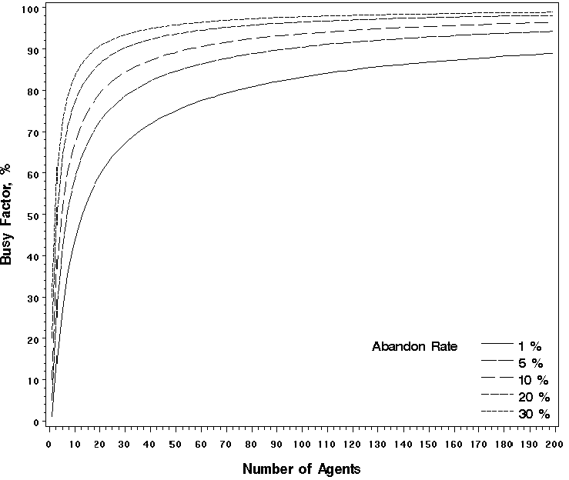
Figure 1. Busy Factor vs. Number of Agents.
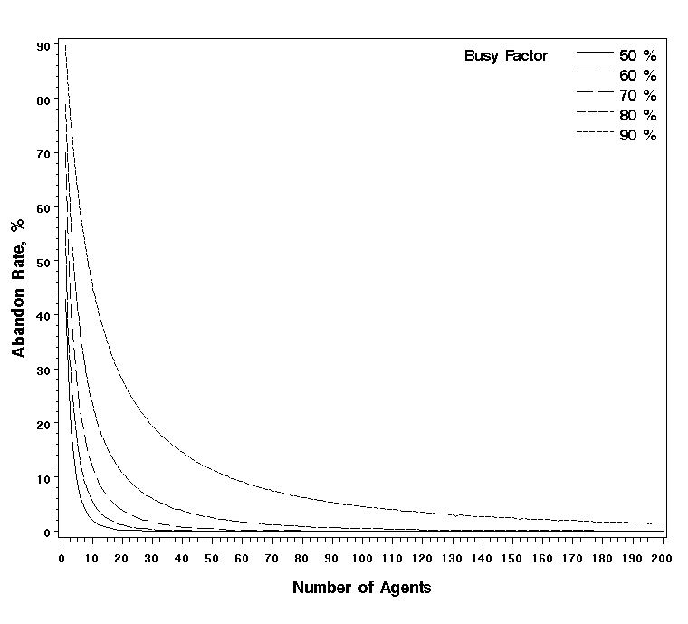
Figure 2. Abandon Rate vs. Number of Agents.

Simulation Results
While there is no single pacing method that works well in all situations, the most appropriate choice depends on your environment. Genesys recommends that you use the Super-Progressive method for relatively small agent groups (30 or less agents). For medium sized groups (30-60 agents), both Super-Progressive and Predictive are suitable. For larger groups, Predictive works fine. The group size issue is depicted in Figure 3, which shows the results of Monte-Carlo experiments. It allows us to compare the efficiency of the Predictive and Super-Progressive methods depending on the number of agents.
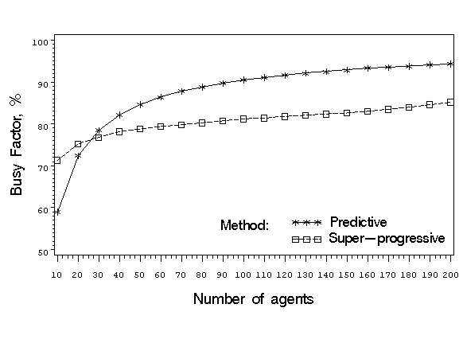
Figure 3. Busy factor vs. Number of Agents. Parameters: AR= 5%, HR = 30%, AHT = 200 sec., PendingDurationTillNoContact = 60 sec. and PendingDurationTillAcceptence = 30 sec.
As you can see, the Predictive method outperforms the Super-Progressive method for relatively large agent groups of 30 or more agents.

Dual Proactive Campaigns
The current PA can work for Dual campaigns when an inbound traffic campaign is combined with a proactive campaign. An inbound chat session, often called reactive, is generated when a customer clicks a special chat button on the web page without any preliminary invitations. This chat session is placed in the same queue as all proactive chats. The following pacing methods can be used for Dual campaigns: Super-Progressive-Dual and Predictive-B-Dual.
A dual proactive campaign requires that Inbound Arrival Rate (IAR) is included in the input parameters for all dual pacing methods. This parameter is estimated from the historical data of the campaign. If IAR is greater than zero, the PA reduces the predicted number of invites, assuming that some agents will be busy serving inbound interactions.
One of the advanced features of a dual proactive campaign is the ability to control inbound traffic. In classic outbound campaigns, the inbound interaction traffic is taken as it is. With GWE, you can either show or hide an inbound chat button on the corresponding customer web page. The dual pacing methods accept Proactive Ratio (PR) as an input parameter. Its possible values are from 0 to 1. The goal is to set a desirable balance between proactive and inbound traffic. A new output parameter Inbound Portion (IP) is also used here. Its possible values are from 0 to 1.
If PR=0, the inbound chat flow remains unchanged and IP=1. The proactive prediction becomes supplementary to keep agents busy enough and satisfy the optimization goal.
If PR=1, the inbound chat sessions should be removed from the campaign, consequently IP=0.
If PR is between 0 and 1, the PA executes the following algorithm. First, it estimates the total optimal incoming chat rate (number of all chats per second) to the agent group. This rate includes both proactive and inbound chats. Next, the portion of IAR in this total rate is calculated. If IAR has greater than 1-PR portion, then the inbound traffic should be reduced to meet the requirement of the proactive chat flow portion specified in the PR parameter. IP output will indicate which portion of the IAR should be left for the near future.
Inbound traffic control does not have an immediate effect. It takes some time for the system to move towards a steady state. Genesys does not recommend that you change the PR input parameter too often. Ideally, it should be the same for several hours.

